***Chemistry***

**10: Liquids and Solids**

**10.4: Phase Diagrams**

55. What phase changes will take place when water is subjected to varying pressure at a constant temperature of 0.005 °C? At 40 °C? At –40 °C?

Solution

At low pressures and 0.005 °C, the water is a gas. As the pressure increases to 4.6 torr, the water becomes a solid; as the pressure increases still more, it becomes a liquid. At 40 °C, water at low pressure is a vapor; at pressures higher than about 75 torr, it converts into a liquid. At –40 °C, water goes from a gas to a solid as the pressure increases above very low values.

57. From the phase diagram for carbon dioxide in Figure 10.33, determine the state of CO2 at:

(a) 20 °C and 1000 kPa

(b) 10 °C and 2000 kPa

(c) 10 °C and 100 kPa

(d) –40 °C and 500 kPa

(e) –80 °C and 1500 kPa

(f) –80 °C and 10 kPa

Solution

(a) gas; (b) gas; (c) gas; (d) gas; (e) solid; (f) gas

59. Consider a cylinder containing a mixture of liquid carbon dioxide in equilibrium with gaseous carbon dioxide at an initial pressure of 65 atm and a temperature of 20 °C. Sketch a plot depicting the change in the cylinder pressure with time as gaseous carbon dioxide is released at constant temperature.

Solution

The carbon dioxide pressure will remain roughly constant at 65 atm (the equilibrium vapor pressure of CO2 at 20 °C) as long as liquid CO2 remains in the cylinder. The gas released from the cylinder will be replaced by vaporization of the liquid. When all the liquid has vaporized, the tank pressure will drop as the cylinder continues to release gas:

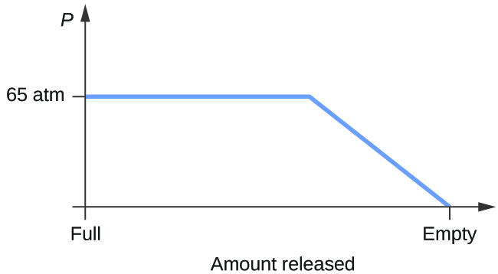

61. If a severe storm results in the loss of electricity, it may be necessary to use a clothesline to dry laundry. In many parts of the country in the dead of winter, the clothes will quickly freeze when they are hung on the line. If it does not snow, will they dry anyway? Explain your answer.

Solution

Yes, ice will sublime, although it may take it several days. Ice has a small vapor pressure, and some ice molecules form gas and escape from the ice crystals. As time passes, more and more solid converts to gas until eventually the clothes are dry.

63. Elemental carbon has one gas phase, one liquid phase, and three different solid phases, as shown in the phase diagram:

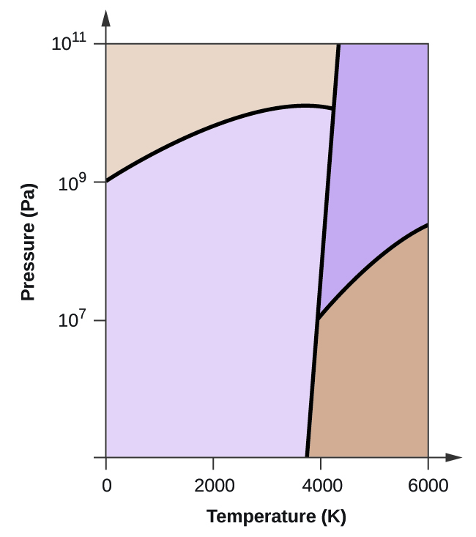

(a) On the phase diagram, label the gas and liquid regions.

(b) Graphite is the most stable phase of carbon at normal conditions. On the phase diagram, label the graphite phase.

(c) If graphite at normal conditions is heated to 2500 K while the pressure is increased to 1010 Pa, it is converted into diamond. Label the diamond phase.

(d) Circle each triple point on the phase diagram.

(e) In what phase does carbon exist at 5000 K and 108 Pa?

(f) If the temperature of a sample of carbon increases from 3000 K to 5000 K at a constant pressure of 106 Pa, which phase transition occurs, if any?

Solution

(a)

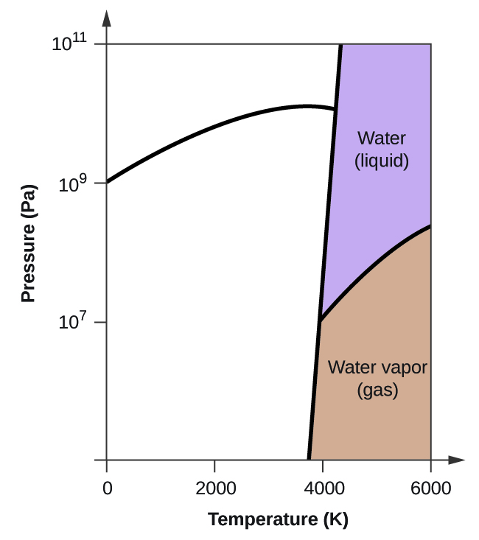

(b)

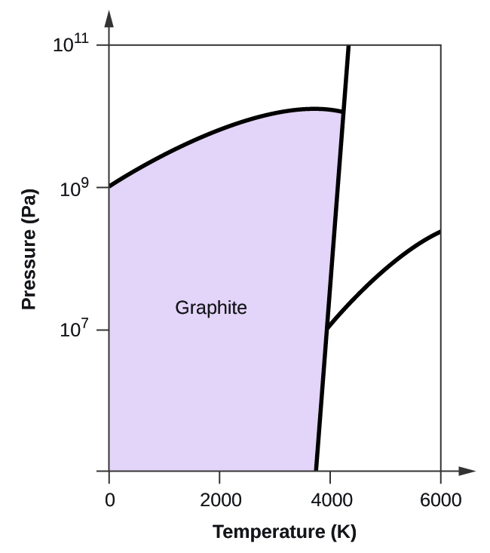

(c)

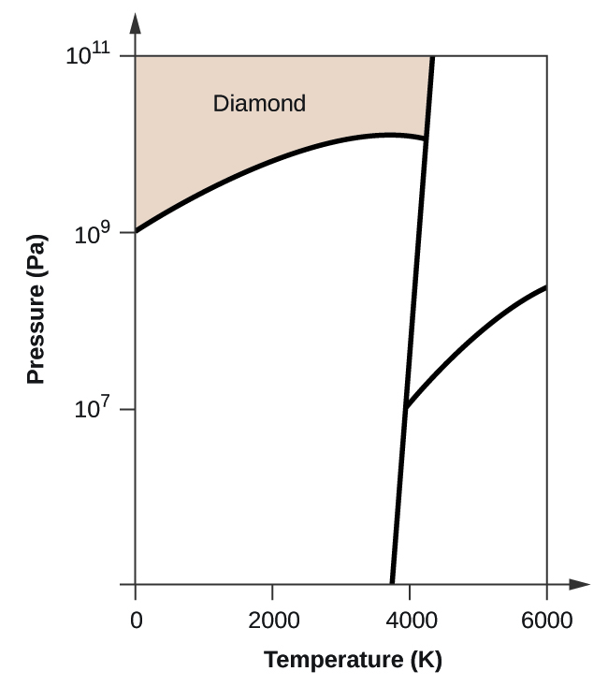

(d)

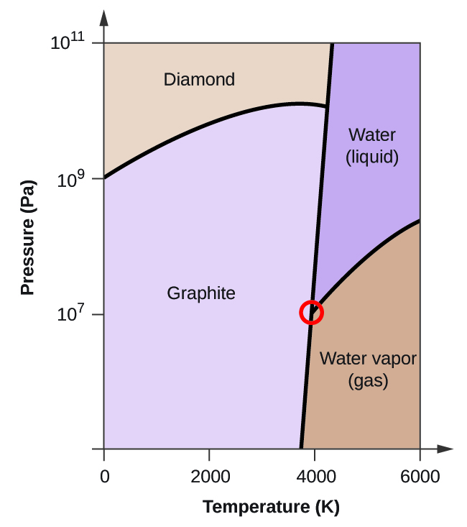

(e) Carbon exists in the liquid phase under these conditions. (f) The phase transition would be one of sublimation. Carbon would convert from graphite to vapor.

This resource file is copyright 2015, Rice University. All Rights Reserved.